If you want to add new server. You add new GameDB, GameServer, SelChar Gate and edit some configuration files

1. Login Server

- Mud 200 Folder’s File
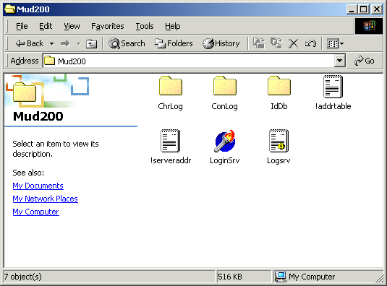

You edit !serveraddr.txt and !addrtable
!serveraddr.txt : it contain GameDB and Game Server’s private IP. You just add new private IP
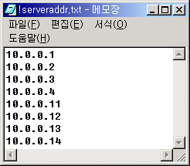
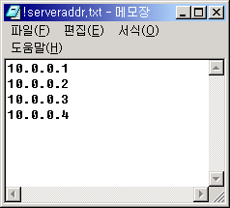

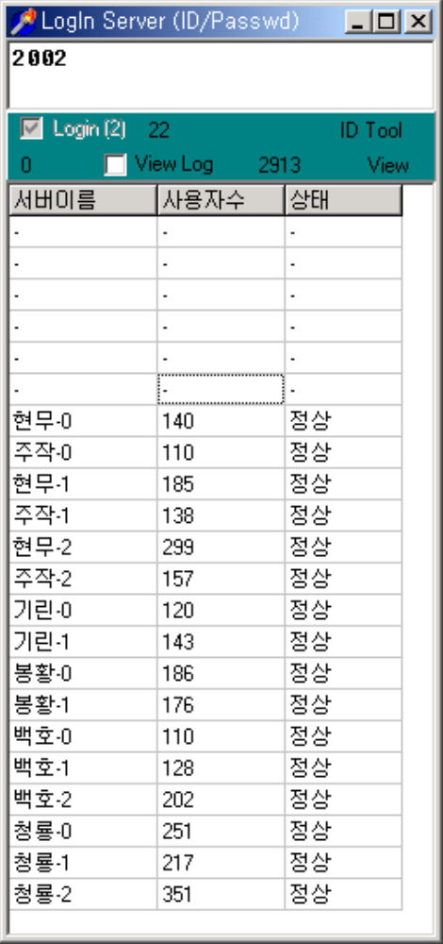
Double Click

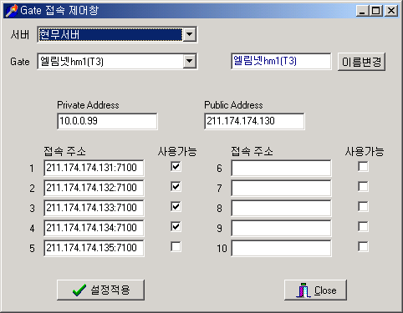
Server Name : Dragon,
Tiger .. etc
SelChar Gate Public IP
Reserved

If you edit Gate connect controller it equal edit !servertable.txt

Login Gate’s Private IP
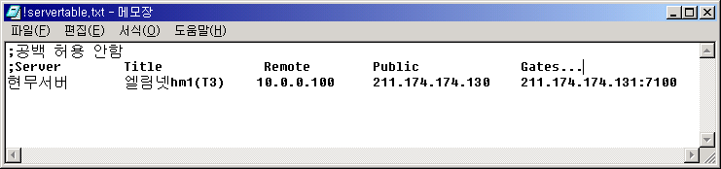
Login Gate’s Public IP
SelChar,Run Gate’s Public IP and Port
2. Game Server
you use the same program in all running server’s file(DB Server, Game server, Game Gate server)

- Copy All program
- Delete Game DB’s Mir.DB, Hum.DB, Fee.DB files
- Delete Guild Folder’s Guildlist.txt and Guild File
- Edit All Public and Private IP in GameServer, Game DB, SelChar Gate, Game Gate
- Edit GameServer’s !setup.txt file
[Server]
ServerIndex =
ServerName =
VentureServer = FLASE
TestServer = TRUE(noncommercial Service) (Commercial Service delete this comment)
LogServerAddr = Log Server Private IP address
LogServerPort = 10001 ~ 각 서버마다 셋트마다 다르게 설정.
[Setup]
ItemNumber = 1
6. Edit DB Server’s !addrtable.txt, !serverinfo.txt, dbsrc.ini

